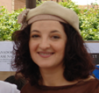
PROF. ELENA C. ZAPATERO CABAÑAS
PROFESSOR AT THE UNIVERSITY OF ALCALÁ (ALCALÁ DE HENARES, MADRID),
MATHEMATICA DEPARMENT SINCE 2001
PROFESSOR AT THE SECONDARY SCHOOL SINCE 2001.
MEMBER OF SPANISH CARTOGRAPHIC ASSOCIATION (IN COMISION CARTOGRAPHY AND CHILDREN) SINCE 2003
VOLUNTEER IN ACTIONAID GROUP OF ALCALÁ SINCE 2005
THIRD DEGREE STUDENT AT THE UNIVERSITY OF ALCALÁ, ABOUT CARTOGRAPHY.

MAPS PRESELECTION AT THE SOLIDARITY WEEK OF HUMAN RIGHTS COUNCIL OF ALCALA DE HENARES TO ENCOURAGE THE PARTICIPATION OF THE STUDENTS AT PRIMARY AND SECONDARY SCHOOL IN BARBARA PETCHENIK MAP´S COMPETITION BY N.G.O. (COORDINATED BY ACTIONAID GROUP OF ALCALÁ)
E. Zapatero Cabañas, Professor at University of Alcalá and Secondary School of Meco. Member of Spanish Cartographic Association (Comission Cartography and Children). Volunteer in ActionAid Alcalá.
J.Manuel Ortiz Santos, Computer Programmer-Analyst, Comunity of Madrid. Director ActionAid Alcalá.

This iniciative starts from the Ayuda en Acción (ActionAid) volunteers group of Alcalá de Henares (Madrid), a Non Governmental Organization (NGO) for Cooperation and Development, and is developed in the Cooperation and Human Rights Council of the city of Alcalá de Henares (made up of Political representants, Non Governmental Organizations (like UNICEF Alcalá, MPDL -Freedom, no Arms and Peace Association-, Solidarity Group Against External Debt, ActionAid Alcalá ,etc) and Citizen Assotiations (like Local Women Council, University of Alcalá (CICODE), Parents of Students at Primary and Secondary School Association,etc). Education and Youth Councils will collaborate too.
Cooperation Council of Alcalá workgroup (only some NGO´s volunteers coordinated by the Cooperation councillor) have developed some sensitizing activities in Secondary Schools of Alcalá: Women Rights and Equality Gender, Soustenible Development (Fair Trade included) and Extreme Poverty since : 2004/05 academic course. Barbara Petchenik Map´s Competition appears in this 2006/07 academic course like a transverse activity throught these last ones.
The main objective of our local phase of the Competition is to fixing on children and young´s mind the value of Equality between all the children and people, independently of the country, gender and the race that belong to, like base of the solidarity,making an artistic and cultural activity. The aim is promoting students´ awareness of their own World. Beyond the Cartographical and Geographical Knowledge and artistic expression (relevant itself, of course), children and adolescents could find a very important Solidarity dimension in Barbara Petchenik Map´s Competition: “Many lands, one world”. This interdisciplinary activity makes students aware of the World they live, comparing “their way of being in their World” with “other ways of being in the World by other children and adolescents from other countries” .
The ActionAid group of Alcalá designed an action plannig including meetings and documents as follows:
- 21st FEBRAURY 2007: Cooperation and Human Rights Council of Alcalá de Henares sent LETTERS (see ANNEX Nº1) TO ALL DIRECTORS OF PRIMARY AND SECONDARY SCHOOLS OF ALCALÁ DE HENARES. Including a POSTER (see annex nº4 ) AND SOME PAMPHLETS FOR STUDENTS (see ANNEX Nº2, figure 1) including rules of local phase of Barbara Petchenik Map´s Competition.
- 1st MARCH 2007: LOCAL MEDIA. Clips of local Newspapers about the Competition (see ANNEX Nº3 , figure 2)
- MARCH 2007: EDUCATIONAL COUNCILS OF MECO AND VILLALBILLA JOINED TO LOCAL PHASE OF COMPETITION INVITED BY THE COOPERATION COUNCIL OF ALCALA. Unicef (Julita Campos) as coordinator of Competition in Town Council of Villalbilla and ActionAid (Elena Zapatero) as coordinator of Competition in Meco, as well as the three Councils: Alcalá, Meco and Villalbilla.
- 26-29th MARCH 2007: BARBARA PETCHENIK WORKSHOP AT CULTURAL WEEK OF SECONDARY SCHOOL OF MECO, IES GASPAR SANZ, ORGANIZED BY ELENA ZAPATERO AS TEACHER (as well as coordinator of local and national phases of BARBARA PETCHENIK´S COMPETITION, member of Spanish Cartographic Association and ActionAid volunteers group of Alcalá).
(see ANNEX Nº4 )
- FEBRAURY, MARCH, APRIL AND MAY: sensitization activities at some secondary (Equality Gender, Fair Trade,etc) schools of Alcalá allowed meetings about Barbara Petchenik Children Map´s Competition by Unicef and ActionAid.
- 1,2,3 JUNE: 6thSOLIDARITY WEEK: EXHIBITION OF PARTICIPANT MAPS (winner included), ( see ANNEX Nº6) AND PRIZE GIVING CEREMONY (see ANNEX Nº7 ) ON MADRID T.V.:”TELEMADRID”

ANNEX Nº1: LETTER TO DIRECTORS OF SCHOOLS
IES ….(PRIMARY OR SECONDARY SCHOOL NAME…)

Alcalá de Henares, 21st febraury, 2007

Dear Director:
Cooperation Council of Alcalá workgroup (only some NGO´s volunteers coordinated by the Cooperation councillor) have developed some sensitizing activities in Secondary Schools of Alcalá: Women Rights and Equality Gender, Soustenible Development (Fair Trade included) and Extreme Poverty since : 2004/05 academic course for our students and other ones to promote to awaness of The Third World and South Countries for the rest of citizen of Alcalá.
In this way, from Town Council of Alcalá, we´ll introduce a new solidarity activitie: World Map Competition for Children (until sixteen years old) Barbara Petchenik during 2006/07 academic course. All participating maps will be exhibited in Cervantes Square at VI Week of Solidarity (during first weekend in June), organized by Cooperation and Culture Council.
This competition will be the local phase (coordinated by Cooperation Council of Alcalá), previous to national phase (coordinated by Spanish Association of Cartography, Pilar Sánchez Ortiz), previous too to international-world Map Competition Barbara Petchenik in Moscow, this time, (coordinated by International Cartographic Association). “Many nations, One World” is the Solidarity Message that ICA has choosen for this Competition. The rules for local phase are included in this letter in a pamphlet with two faces (see you annex II).
The main objective of our local phase of the Competition is to fixing on children and young´s mind the value of Equality between all the children and people, independently of the country and the race that belong to, like base of the solidarity, through the realization of an artistic and cultural activity…etc
From the Local Council of Cooperation to Development and Human rights, we consider interesting the participation in the World Competition of Maps of students, so we request your collaboration and all the School´s (especially the professors and departments of Geography, Plastic and Psychologist´s).
More Information: Organizing Comitee: Elena Zapatero Cabañas (elena.zapatero@uah.es), José Manuel Ortiz Santos (elpichu@telefonica.net) and Lucía Trillo from Cooperation Council: 91 887 05 86.
It would be very pleasing and honorable for the authorities and citizens of our municipality, to continue having your collaboration, in pro of the solidarity.
Thanking your collaboration ahead of time,

Sincerely,

Fdo.: Elisa de Francisco Ramírez
Councilwoman of Culture and Cooperation

ANNEX Nº2: PAMPLHET INCLUDING RULES OF LOCAL COMPETITION
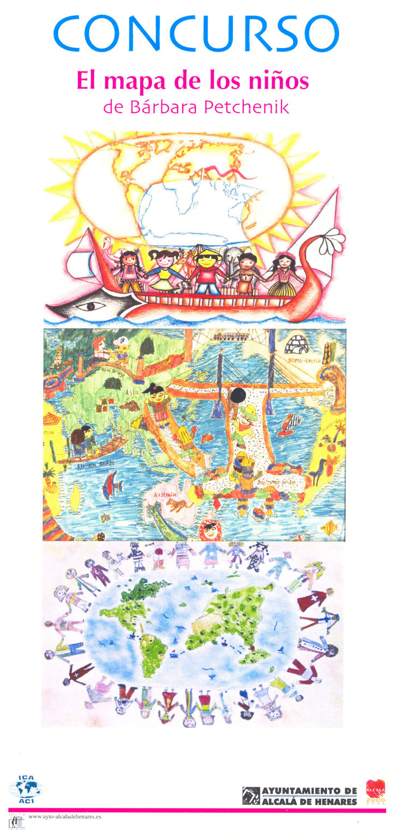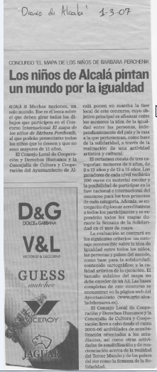
Figure 1 Figure2
Figure 1: Behind the cover of the pamphlet: “CONCURSO El mapa de los niños de Barbara Petchenik” (above in the left) there is the following test:
Rules of the local phase of Competition "The map of Bárbara's children Petchenik"
- The topic is: "Many nations, a single world."
- The judging will focus on three criteria: 1) a recognizable message about the idea of equality among all the children, people and countries of the world, like base for the solidarity, 2) cartographic content, and 3) the artistic quality of the execution.
- The maximum size of a map should not exceed of an A3 (420 millimeters x 297 millimeters). Any number of the "systems of the projection" you can use to generate the coast lines and another material bases (e.g. the international limits). These can include to go back or to copy an existent map of the world or to use a computer program.
- Each map should have the following information in form of an enclosed sign in the part of behind of the representation: name and the author's age or authors, address of the school, their author's country, and the title of the map.
- Three categories: under 9 years, 9 to 12 years and 12 to 15 years.
- Local phase: 200 Eurus in school material to the winner of each category and Certificate to all the participants and the school centers.
- National phase: the three more good of each category they will be presented to the national phase, where the five better maps will be chosen to be correspondents to the international phase. The elects will still have a prize to determine.
- International phase: the winning maps will be donated to UNICEF for their possible use in the Christmas postcards of Unicef.
- Place of presentation of maps: Town council of Culture and Cooperation.
- Presentation term: March 1 at April 27.
- The jury would be composed by:
- Councilwoman of Cooperation of Alcalá, Councilwoman of Education of Meco and Villalbilla.
- Four people belonging to the associations members of the Local Council of Cooperation to Development and Human rights. (Julia Campos from Unicef, Elena Zapatero from ActionAid and the City council of Alcalá. All the participating maps will be exhibited for the whole week in Cervantes Square.
- The rules of the local phase competition can be consulted in http://www.ayto-alcaladehenares.es, in the Town council of Cooperation.
- The rules of the international competition are in http://www.icaci.org
- The maps presented to editions previous of the competition are filed in the library of maps of the University of Carleton, in the web http://children.library.carleton.ca - Organizing committee: Elena Zapatero Cabañas (elena.zapatero@uah.es), José Manuel Ortiz Santos (elpichu@telefonica.net) and Lucía Trillo ,Cooperation Council: 91 887 05 86.
ANNEX Nº3: Clip of a local digital newspaper, as figure 2(the local newspaper:”Diario de Alcalá”)
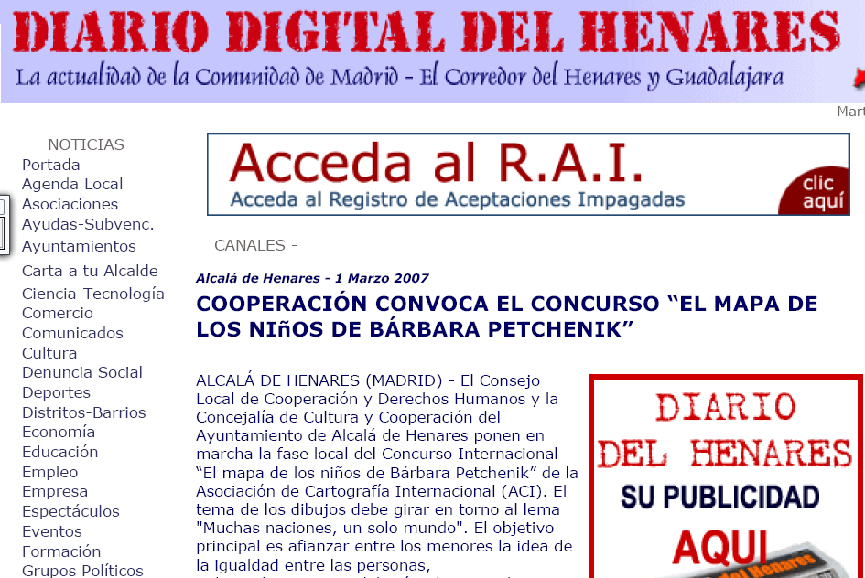
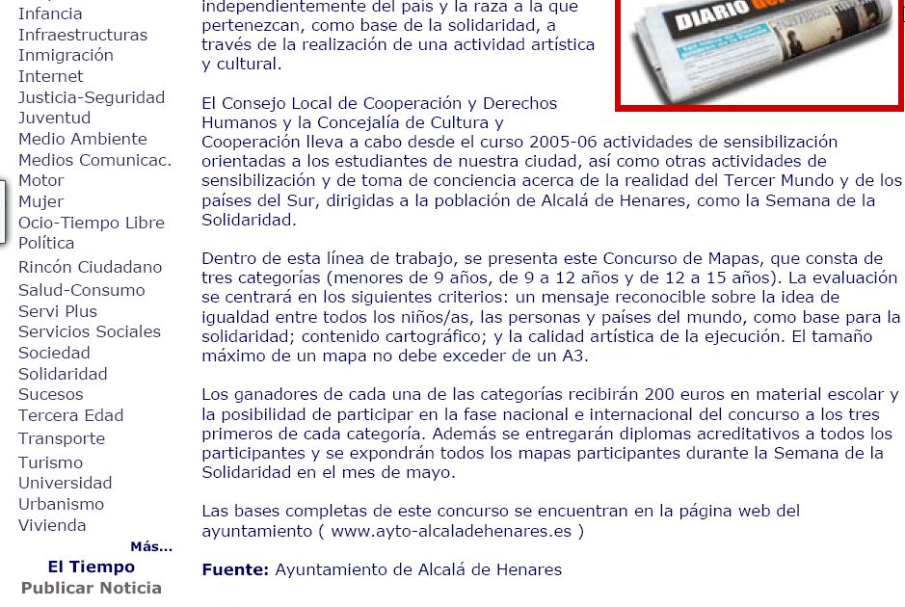

ANNEX Nº4: BARBARA PETCHENIK WORKSHOP AT CULTURAL WEEK OF SECONDARY SCHOOL OF MECO: IES GASPAR SANZ
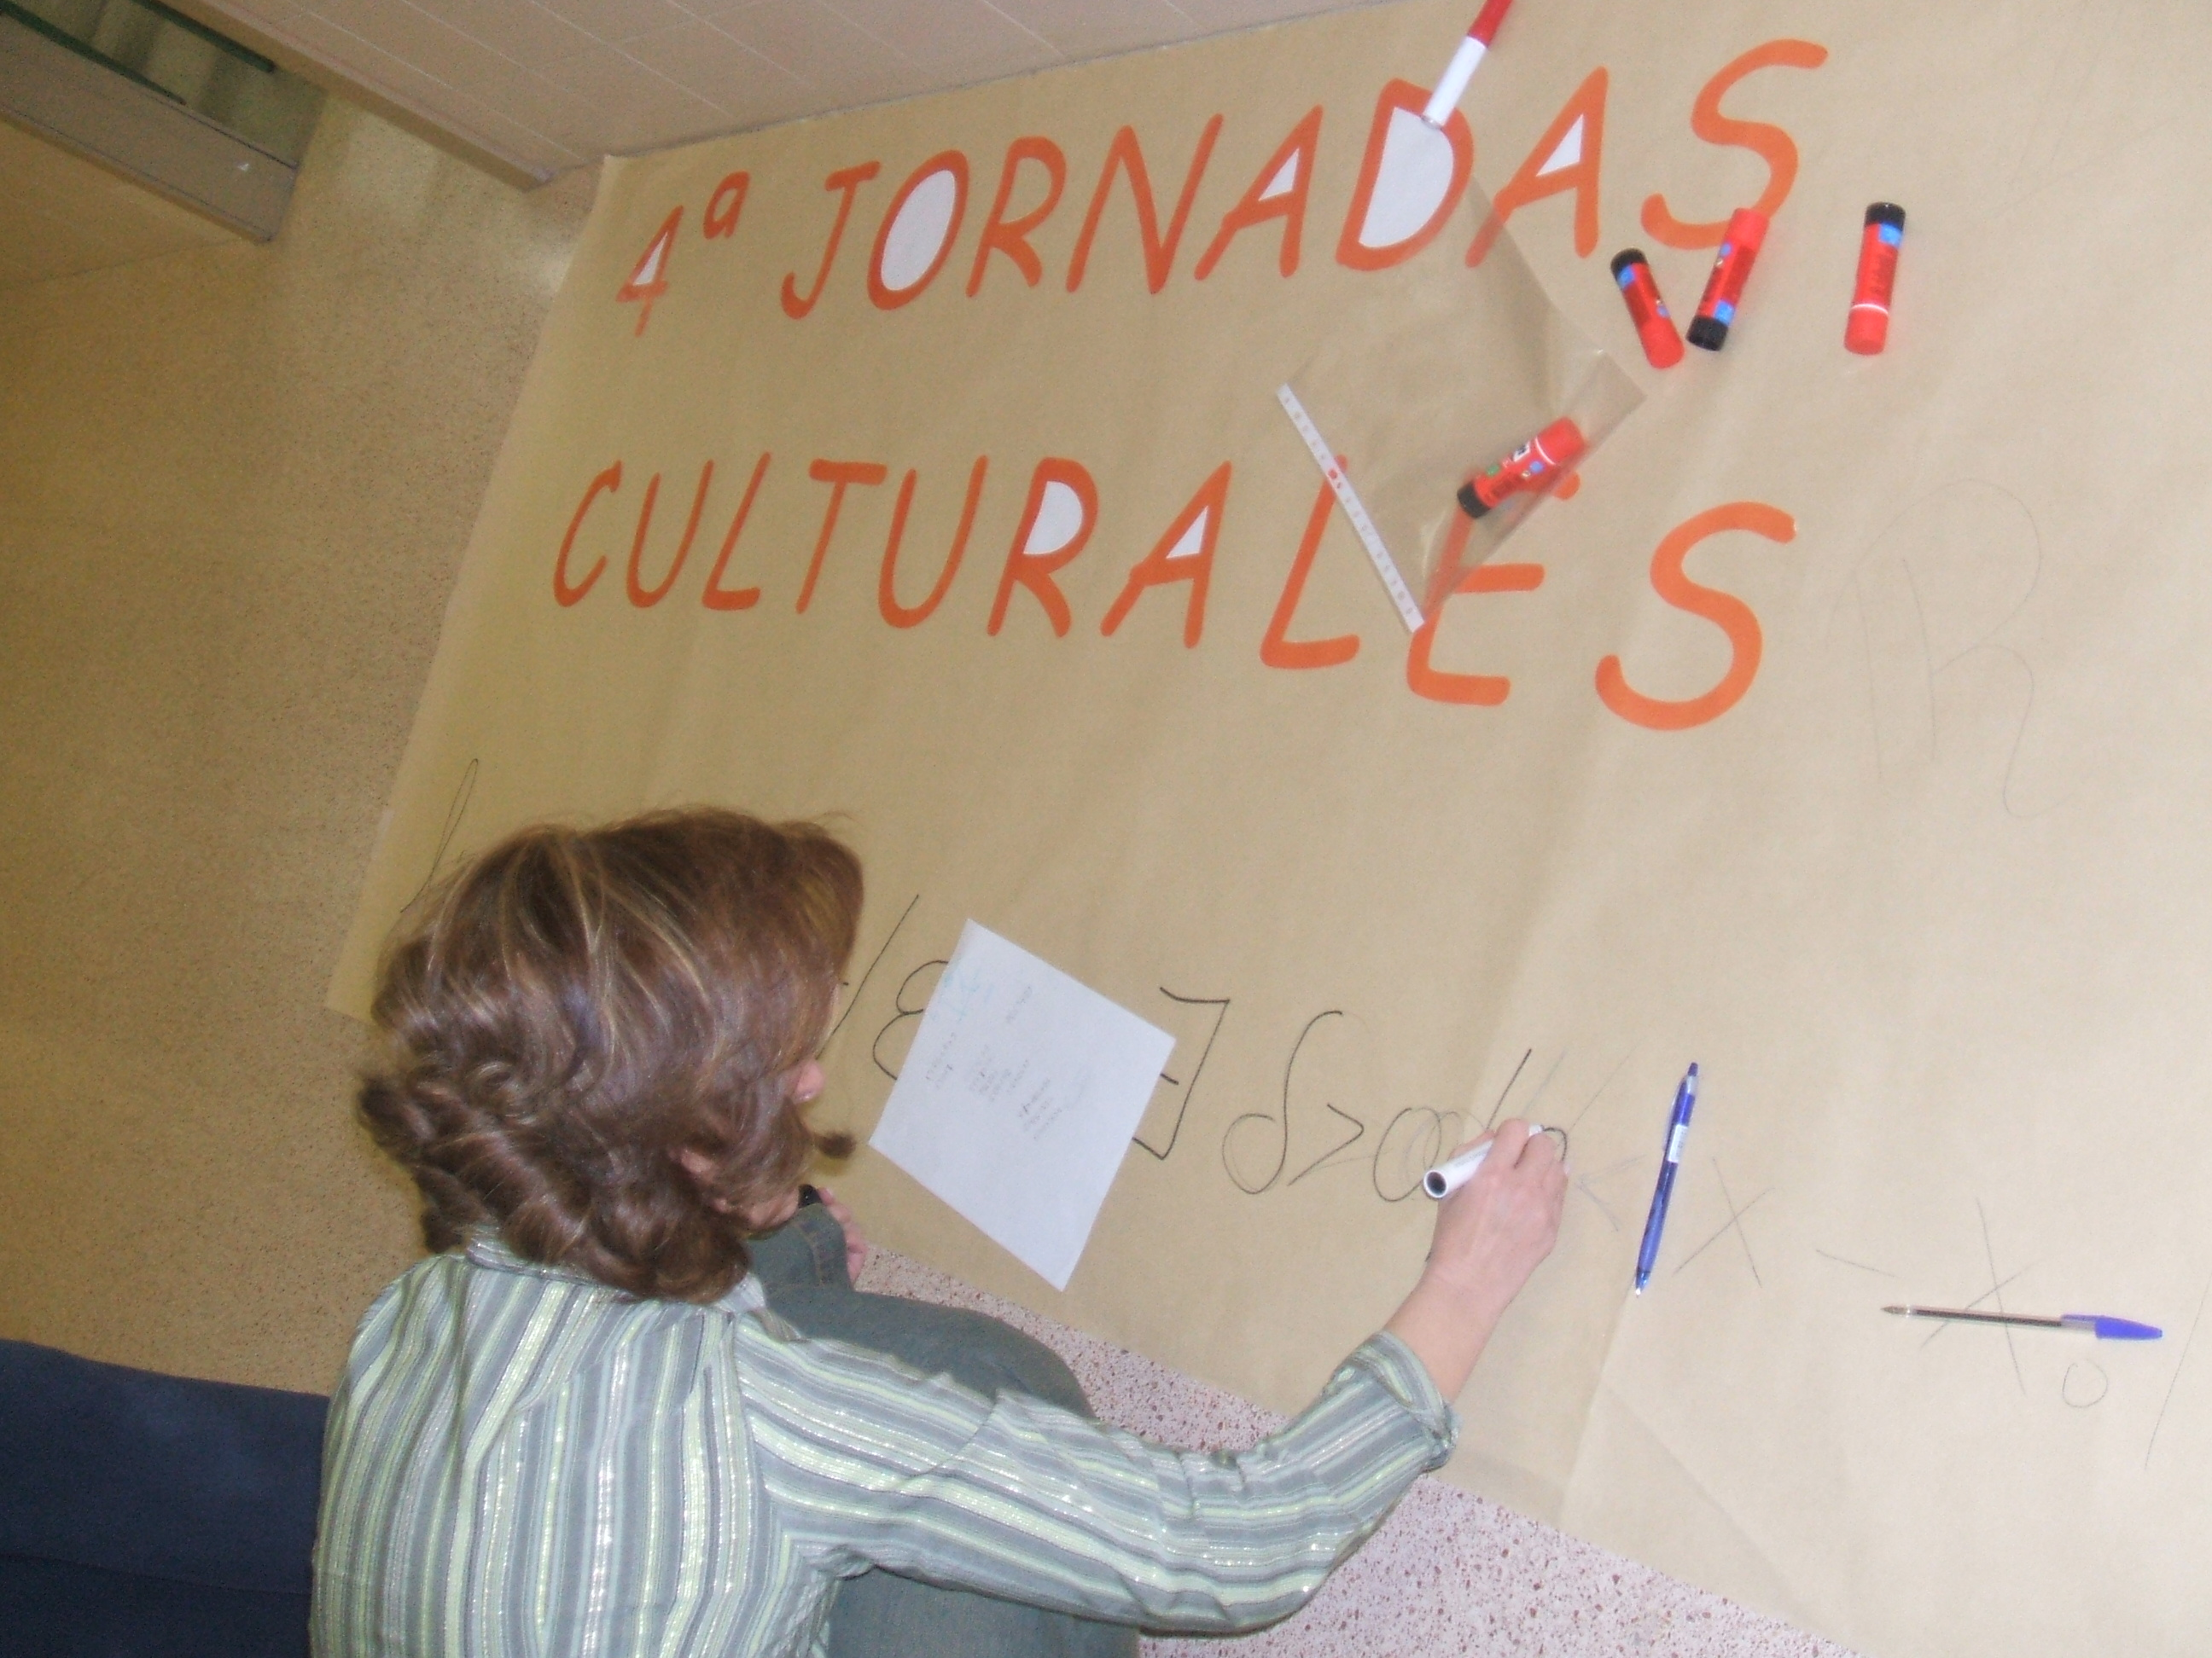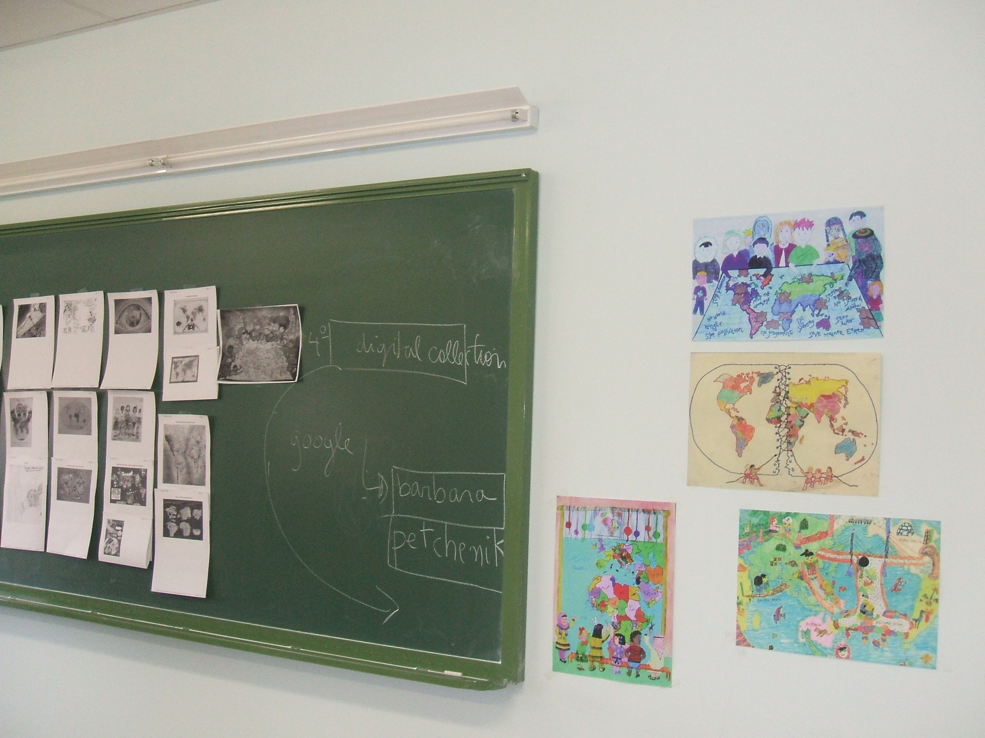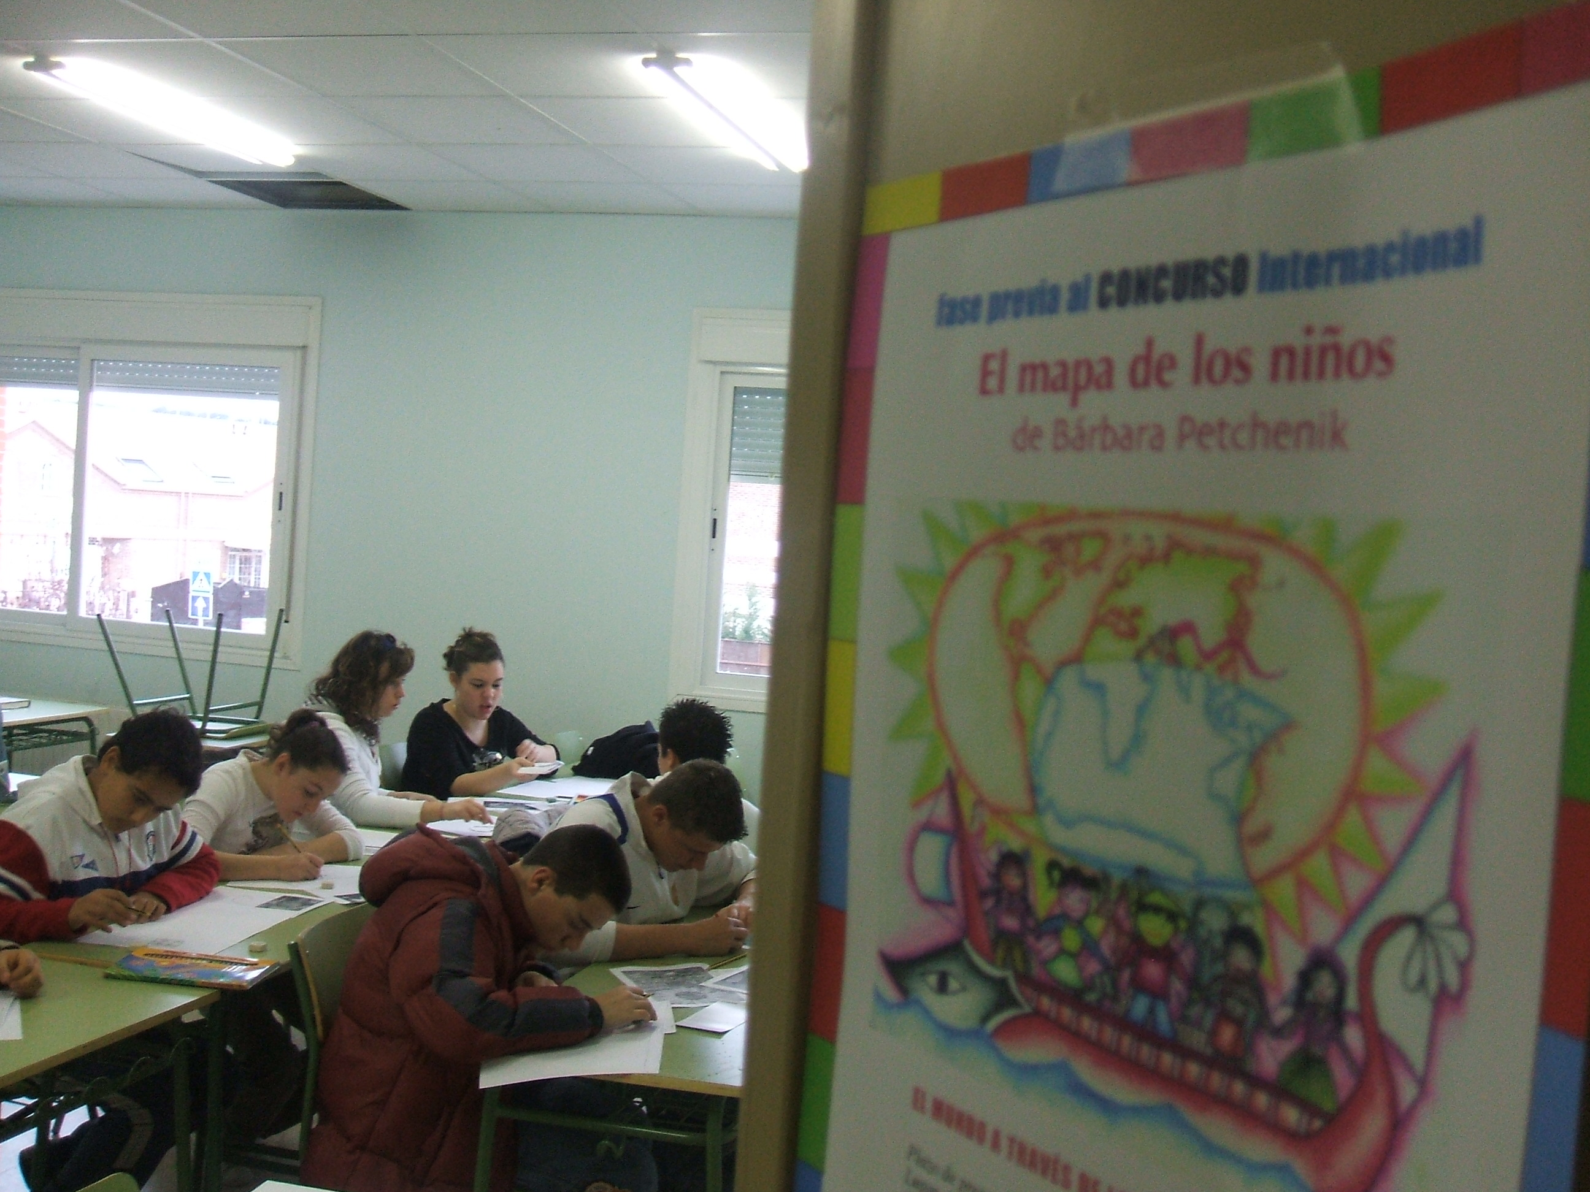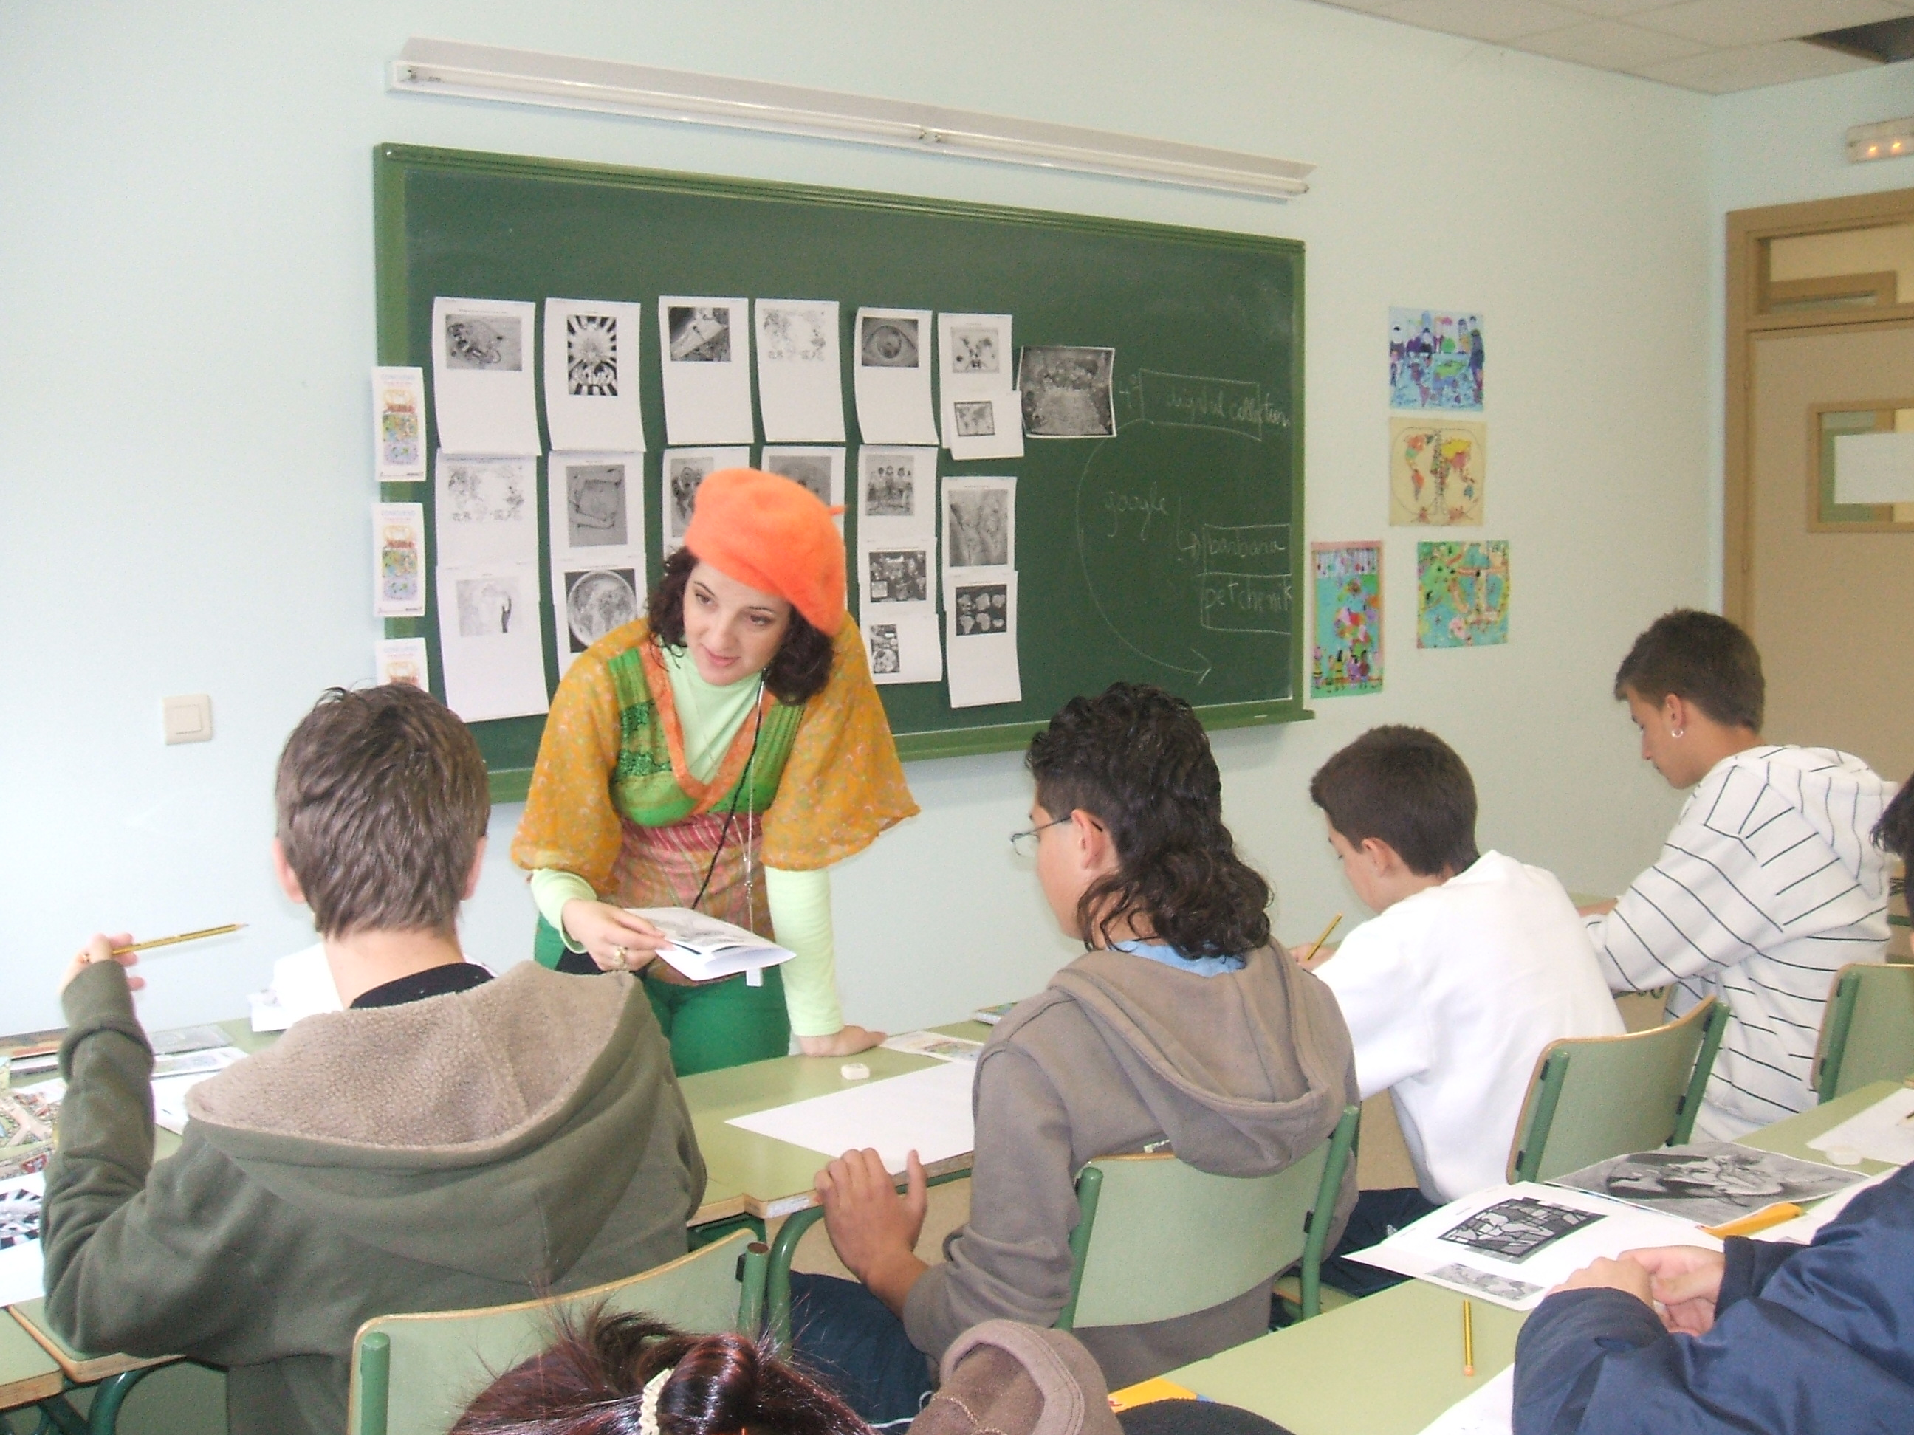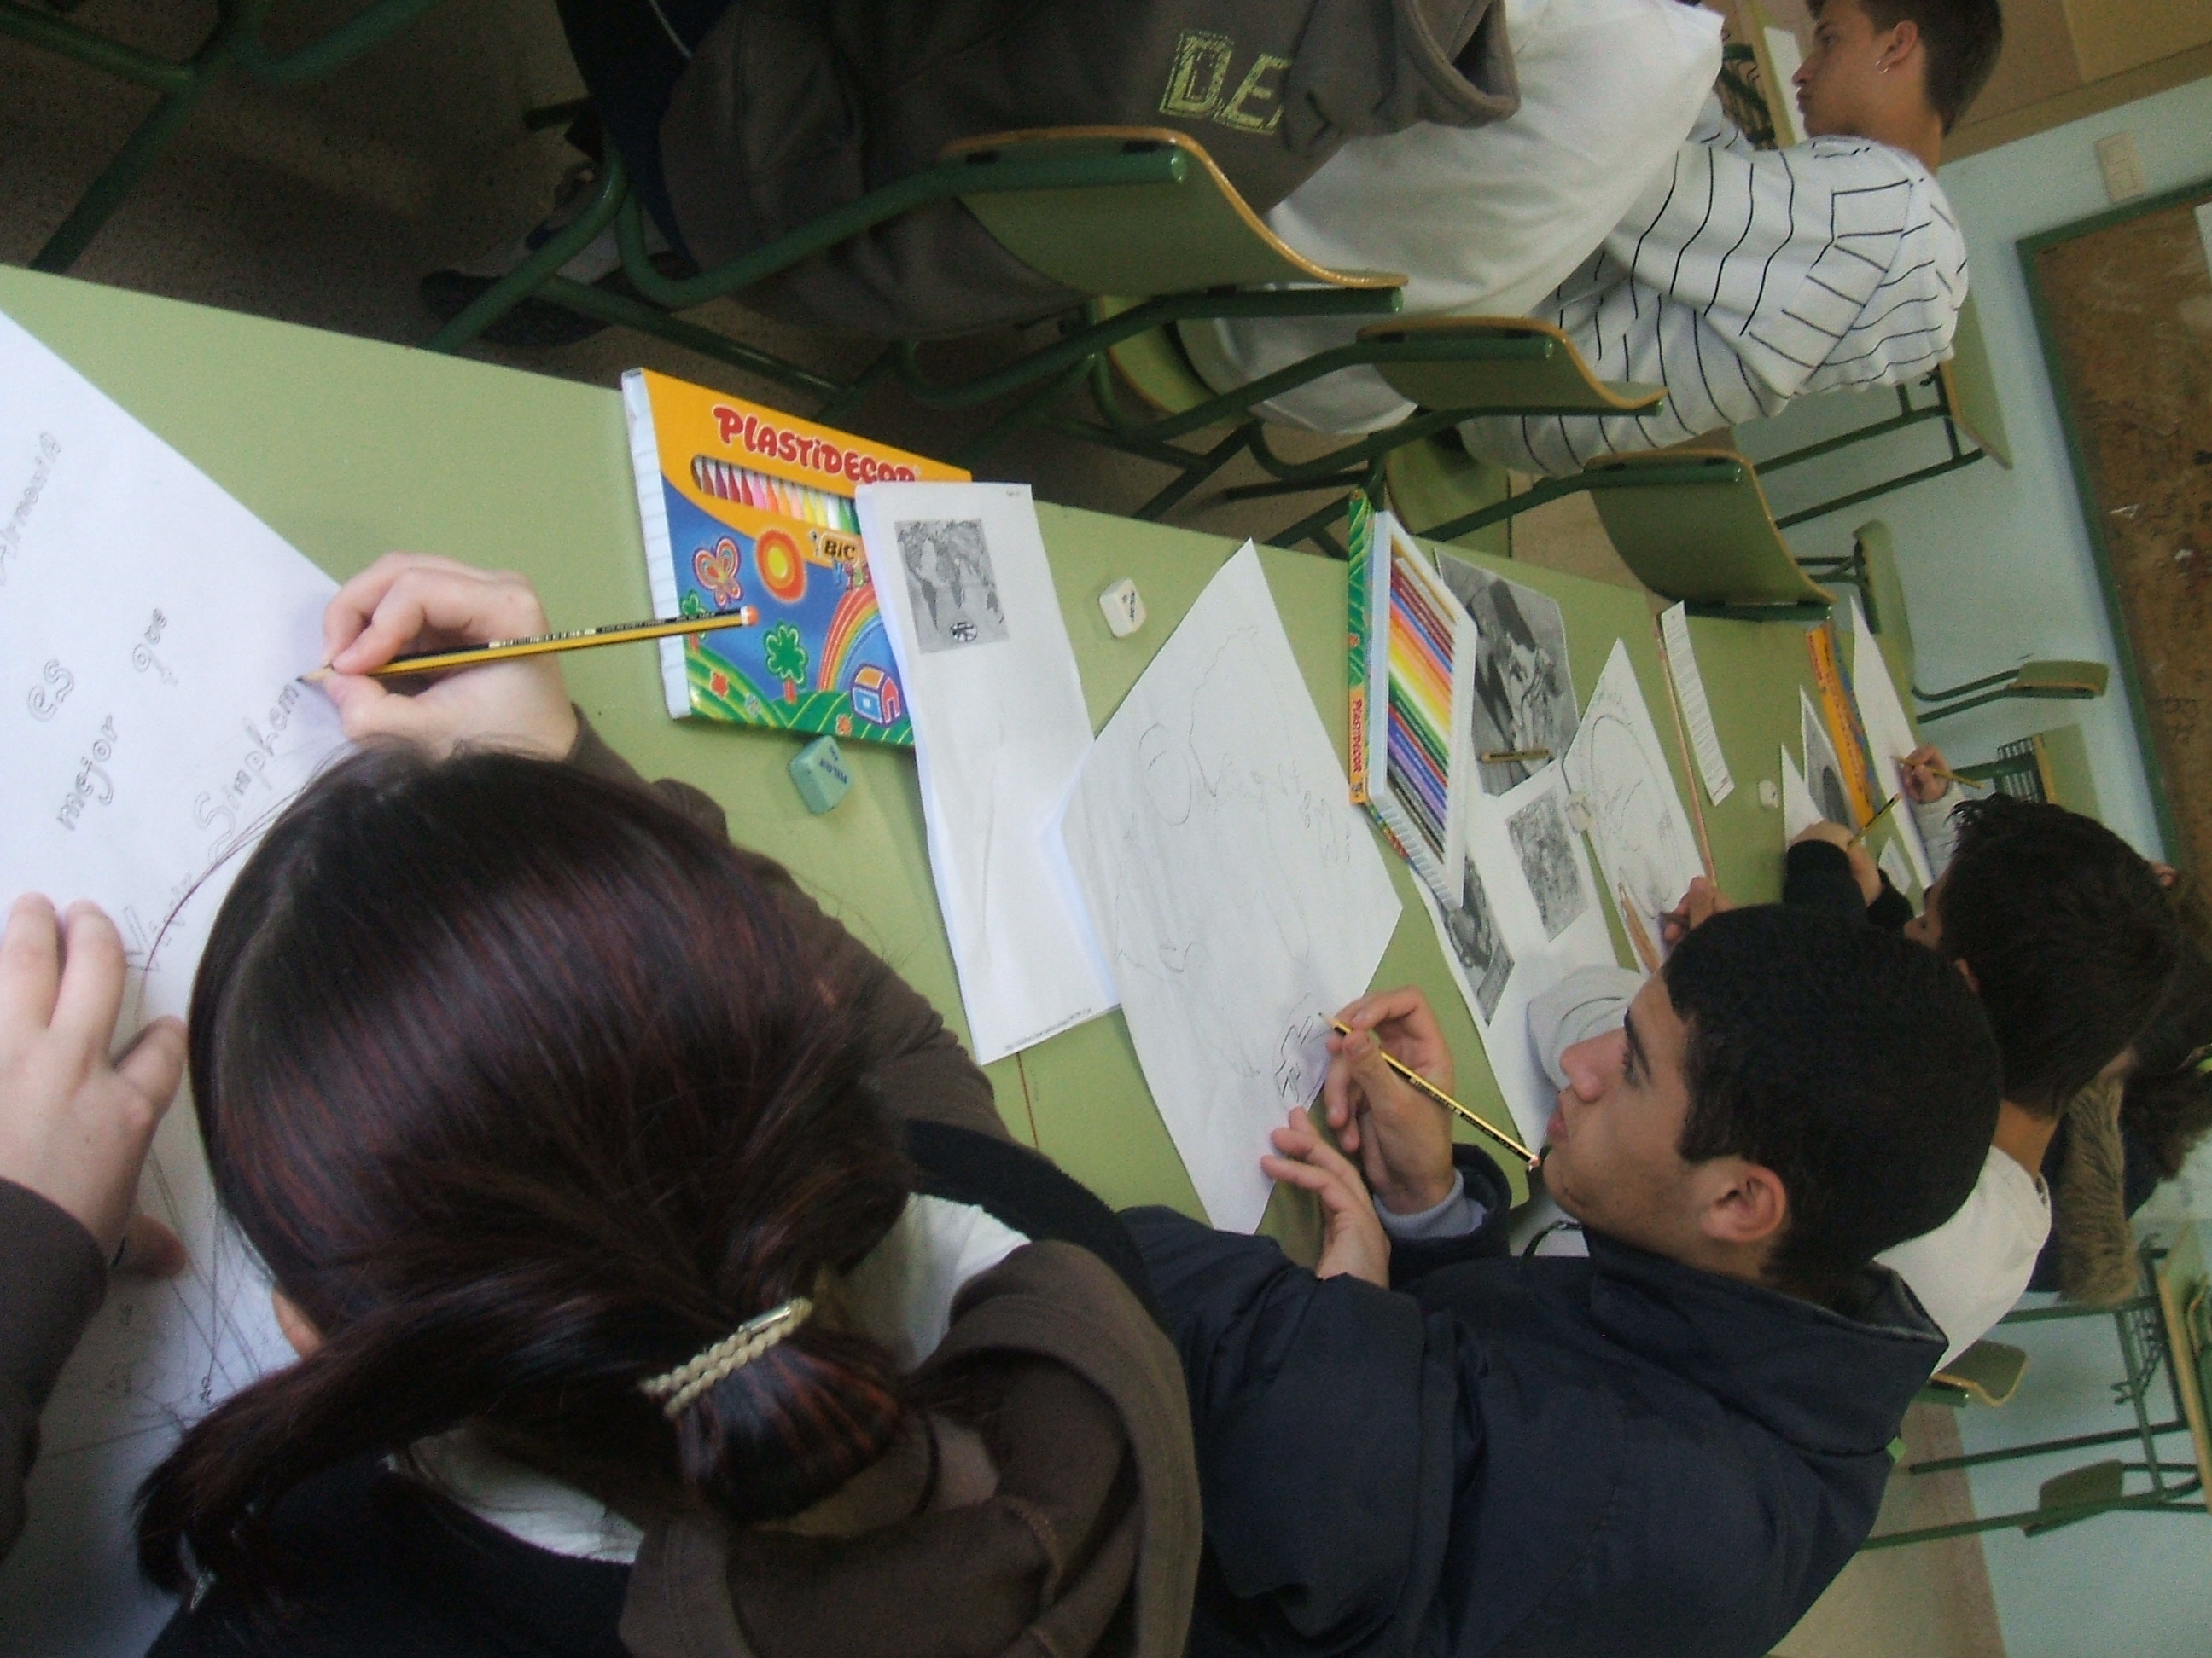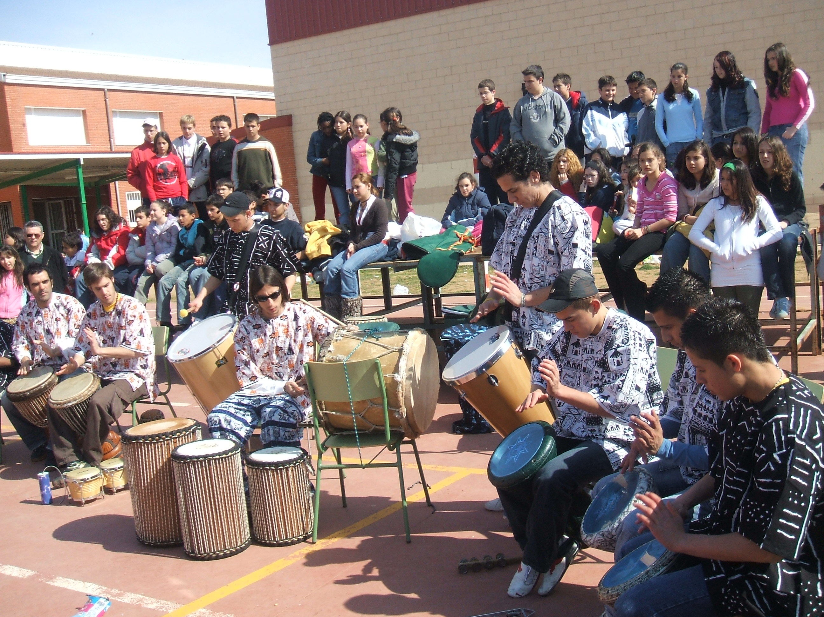

ANNEX Nº5: 6thSOLIDARITY WEEK PLANNING (translation)

IV SEMANA DE LA SOLIDARIDAD (6th SOLIDARITY WEEK)

COMPROMISO SOLIDARIO HACIA EL 2015 (SOLIDARITY OBJECTIVES TO 2015)
2º OBJETIVO:“LOGRAR LA ENSEÑANZA PRIMARIA UNIVERSAL
(2nd OBJECTIVE: “PRIMARY SCHOOL FOR ALL CHILDREN IN THE WORLD”
1 al 3 de junio (1-3 June)

Exposición y venta de artesanía y publicaciones (Exhibition and selling handicrafts, and NGO´s information)
en las casetas de las ONGs.(in stands)
Plaza de Cervantes (Cervantes Square)
Viernes 1 de junio (Friday, 1st June)
18.45 h. Inauguración de casetas (Inauguration of NGO Stands.
(Plaza de Cervantes)

19.00 h. Inauguración de las exposiciones (Inauguration of Exhibitions)
“Educación es vida” de Ayuda en Acción y “Escuela en los
campamentos de refugiados Saharauis en Tinduf (Argelia)”
de la Asociación de Amigos del Pueblo Saharaui de Alcalá de
Henares. (“Education is Life”, ActionAid NGO and “Saharauis Refugees School in Tinduf (Argelia)”, Saharagui people´s Friends Association of Alcalá de Henares)
Planta baja del Ayuntamiento
19.15 h. a 20.00 h. Conferencia: “El cambio climático y la pobreza”(Conference: “Climate Change and Poverty”)
a cargo del profesor D. Antonio Ruíz de Elvira Serra, Catedrático
de Física Aplicada de la U.A. (Phisical Professor at the Autonoma University of Madrid”
Carpa de la Plaza de Cervantes
20.30 h. a 22.00 h. Velada Solidaria de Cuentacuentos (Evenging show with storytelling, free tasting some tea and dates )

Mariola del Pozo, Ana Griot y Juan Alfonso de Légolas Colectivo
Escénico, con interludios musicales a cargo de los alumnos
del Conservatorio de Música de Cámara de Alcalá de Henares,
con degustación de dátiles y té.
Carpa de la Plaza de Cervantes
22.00 h a 23.00 h. Actuación grupo Sedna de danza y percusión
juvenil de la “Asociación Waslala” (Dance and Percussion Performance by Young SEDNA group from “NGO Waslala”
Plaza de Cervantes
Sábado 2 de junio (Saturday, 2nd June)

Horario de casetas (Timetable of NGO´s stands): de 11.00 h. a 14.00 y de 18.00 h. a 23.00 h.
12.00 h a 14.00 h. actividades infantiles “Ningún niño sin colegio”(children´s activities: No Child without School)
con talleres y juegos para niños.
Organiza el grupo de voluntarios de Ayuda en Acción. (Coordinated and Organized by ActionAid volunteers group of Alcalá and Madrid)
Plaza de Cervantes
19.00 a 21.00 h. Mesa Redonda “La Educación”: (Forum: “Education”)

“Fundamentos para la cohesión social” a cargo de Dª Concha
Albertos, Directora del IES Lázaro Carreter de Alcalá de Henares,

“Educación para el Desarrollo de los Pueblos” a cargo Silvia
Cruz, Técnico de Cooperación de Ayuda en Acción en Perú
“Educación para el Desarrollo de los Pueblos”, a cargo deD.

Luis Jiménez, Misionero de la Consolata, desde su experiencia
en Africa.

21.00 – 22.00 h. Actuación musical “Taller demostración de Danzas
del Mundo”(Musical Performance: “Showing- Interactive Workshop of World Dancing”
Plaza de Cervantes

22.00-23.00h. Actuación grupo musical Zacatúm (grupo de Samba) (Musical Performance: Zacatúm Samba Group)
Plaza de Cervantes

23.00 h. Actuación del Cantautor “Luis Pastor”(Songwriter Performance: “Luis Pastor”)
Plaza de Cervantes
Domingo 3 de junio (Sunday, 3th June)

Horario de casetas( timetable of NGO stands): de 11.00 h. a 14.00 y de 18.00 h. a 22.00 h.
11.30 h. a 12.00 h. actividades infantiles☹(child games)

“Juegos Cooperativos y Taller de Globoflexia” (“Cooperative Games and Balloon Workshop”)
Organiza el Grupo de Voluntarios de Ayuda en Acción. (Coordinated by ActionAid volunteers group)

12.00 h. Teatro Infantil Solidario: “El Planeta de la Sonrisa”(Children Theatre performance: “The Planet of the Smile”, “Wawayay” Theatre Company of ActionAid volunteers group of Madrid).
Compañía de Teatro “Wawayay” de Voluntarios de Ayuda en
Acción-Madrid.
Plaza de Cervantes.
12.45 h. Entrega de premios del Concurso de Mapas (fase previa)
de Barbara Petchenik.
(Prize giving ceremony of the Map Competition (local and national winners, the last ones will compete in Moscow,August!!!) Barbara Petchenik)
Con la colaboración de los Ayuntamientos de Meco y Villalbilla y la Sociedad Española de Cartografía. (Town Councils of Alcalá, Meco and Villalbilla, as Spanish Association of Cartography (directed by Pilar Sánchez Ortiz) collaborate and giving prizes, as members of the jury)

Plaza de Cervantes
13.00 h. a 15.00 h. Paella Solidaria, amenizada por el Mariachi “Real Jalisco”.

ANNEX Nº6 : EXHIBITION OF PARTICIPANT AND WINNER´S MAPS
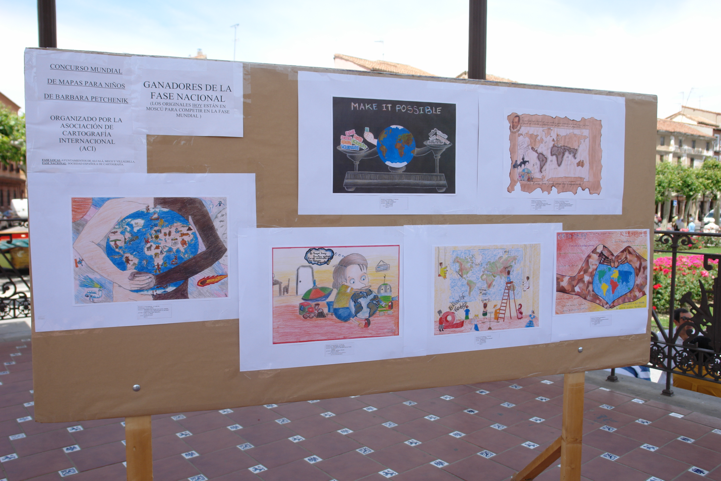
“National winners´Maps”
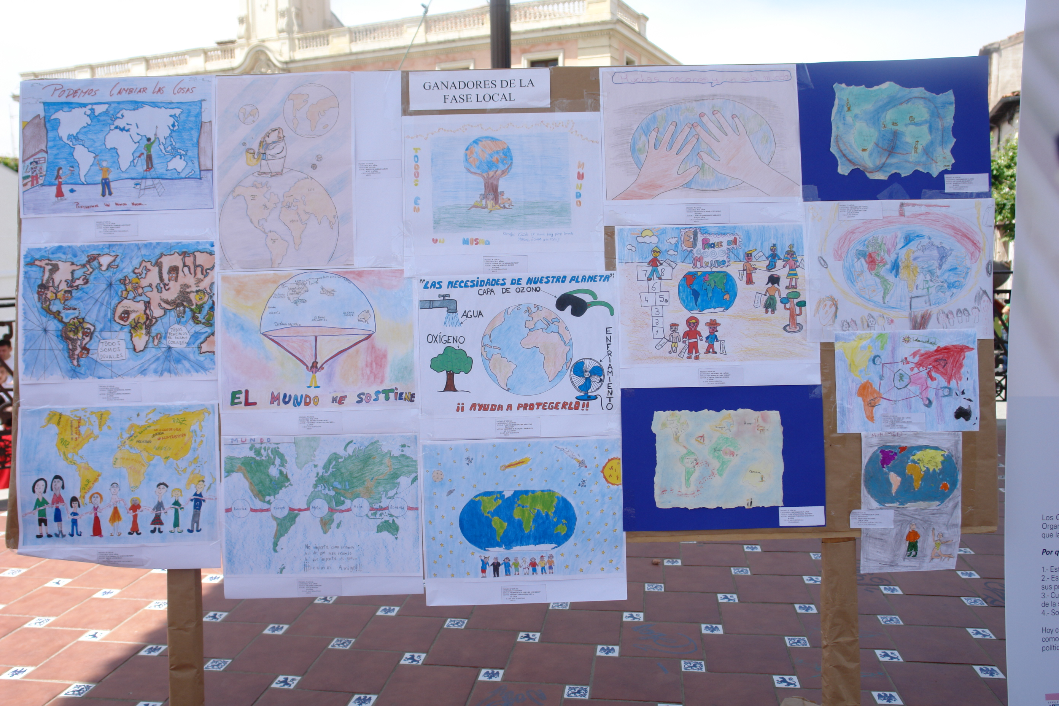
“Local winners´Maps”

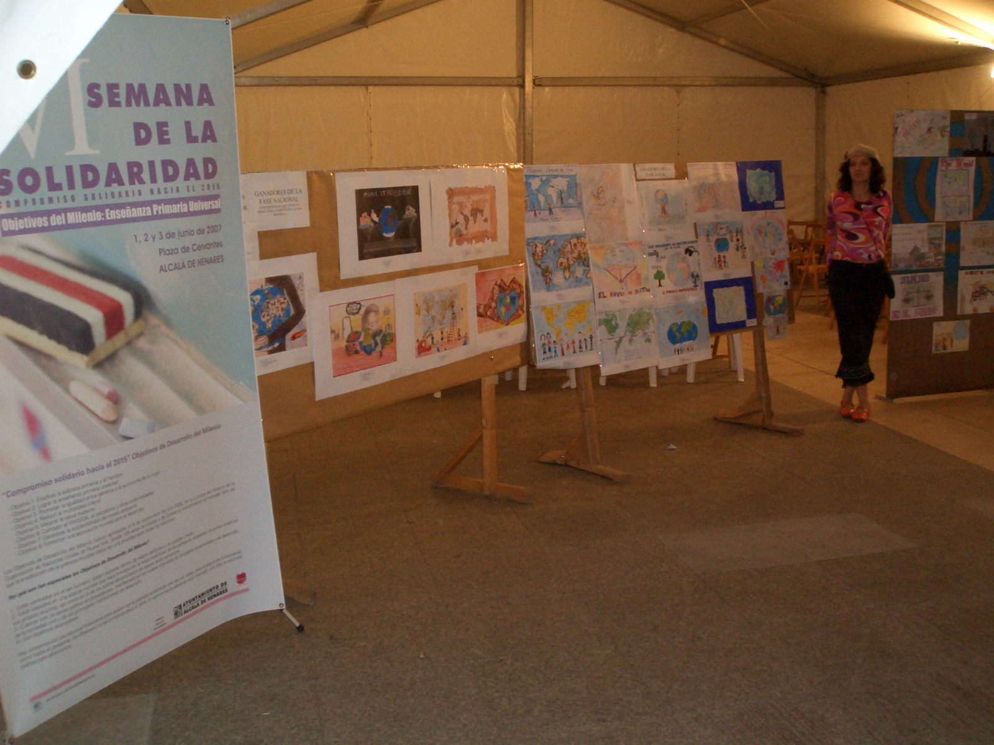
“Both: Local and National Winners´Maps

ANNEX Nº7: PRIZE GIVING CEREMONY AT LOCAL AND NATIONAL PHASES OF BARBARA PETCHENIK´S COMPETITION IN CERVANTES SQUARE

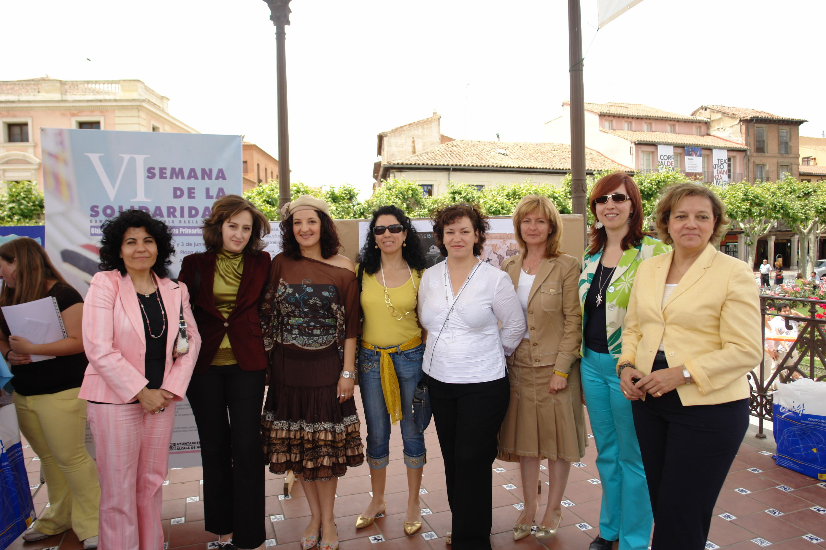
From left to right: Director and members of Spanish Cartographic Association(3), Cooperation Councilwoman of Alcalá and her Secretary, Education Councilwomen of Meco and Villalbilla, and Director of Unicef in Alcalá.
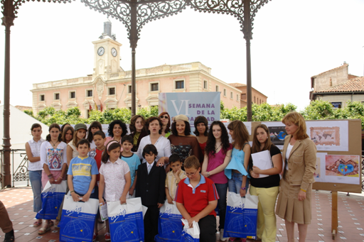 “Local and National Winners in Barbara Petchenik´s

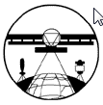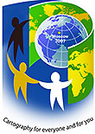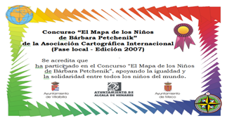

ANNEX Nº8 : CHILDREN´S ACTIVITIES AT THE 6thSOLIDARITY WEEK

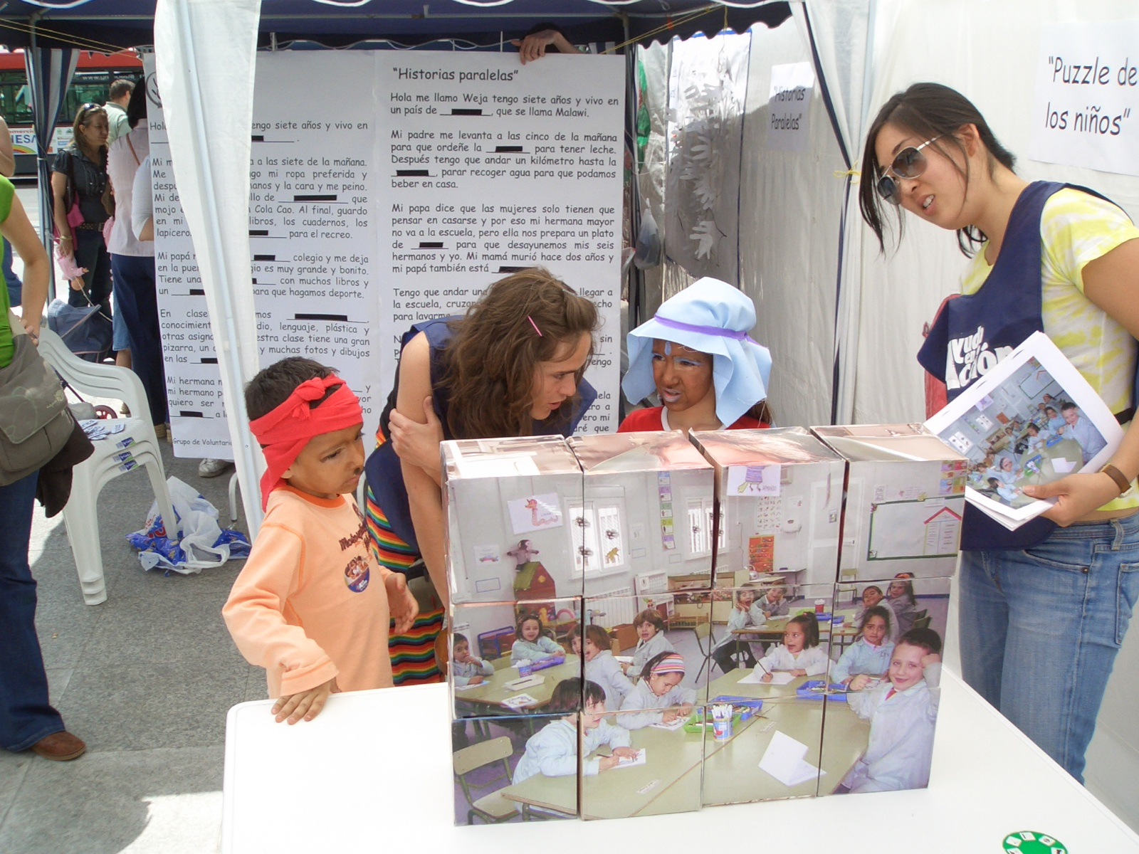
“Children´s puzle” and “Parallel Lives” about 2nd OBJECTIVE: “PRIMARY SCHOOL FOR ALL CHILDREN IN THE WORLD”TO 2015

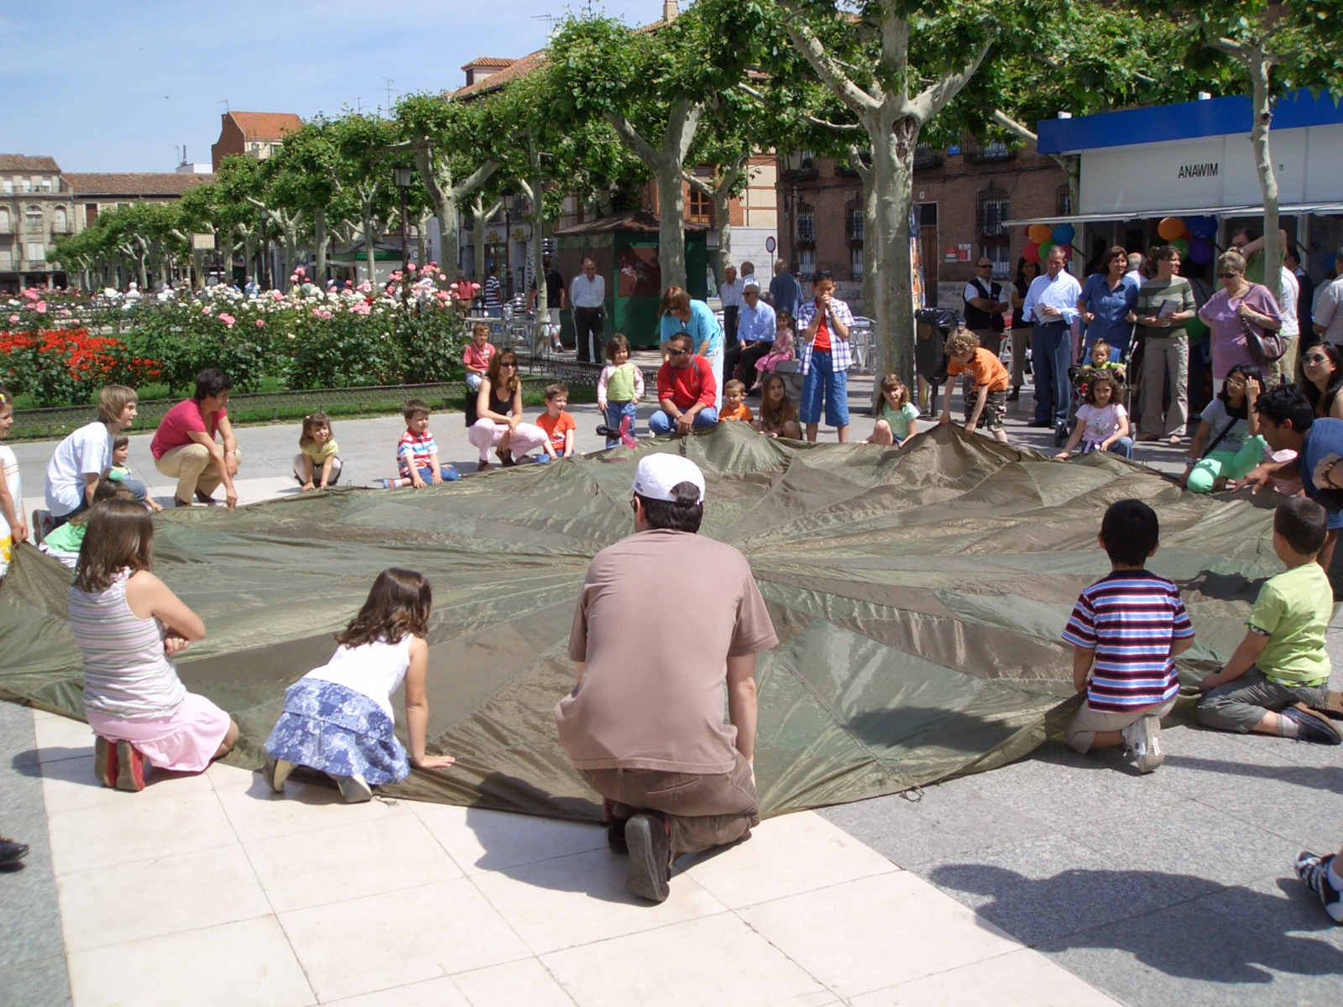
“Cooperative Games with a purchate”

